Rote Song Treasure Hunt
Matt Oomkes

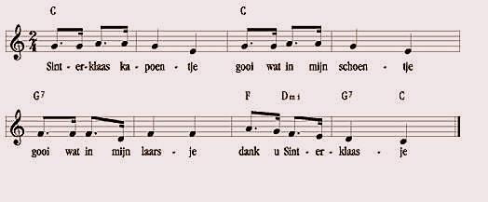
Sinterklass Kapoentje
This song is a Dutch children’s song for St. Nicholas Day (December 6th). It is a song I sung as a child at a annual St. Nicholas Day celebration with my family. The text in Dutch is as follows:

Sinterklaas kapoentje
gooi wat in mijn schoentje
gooi wat in mijn laarsje
dank u Sinterkaasje

Translated to english, it roughly means:

Saint Nicholas, you little rascal
throw something in my shoe,
throw something in my boot,
thank you Saint Nicholas!

It is a Dutch tradition for children to leave their shoes out before the go to bed on the eve of St. Nicholas Day. Overnight, Saint Nicholas (or maybe their parents) would fill the shoes with candy and other gifts. You may notice the ends of each line in dutch ends in “je”. This is the suffix in the Dutch language that refers to something little or small, perfect for rhyming, and fitting in a childrens’ song.

This song is interesting in that it follows a sentence structure. The first two lines of text use the exact same melody (and implied harmony) to form the presentation phrase, while the last four bars uses the rhythmic element of the preceding material, but with different pitches and implied harmonies to form the continuation phrase.

The implied harmony is pretty simple, but does include a IV-ii-V7-I progression in the last two measures.

