August Burchard
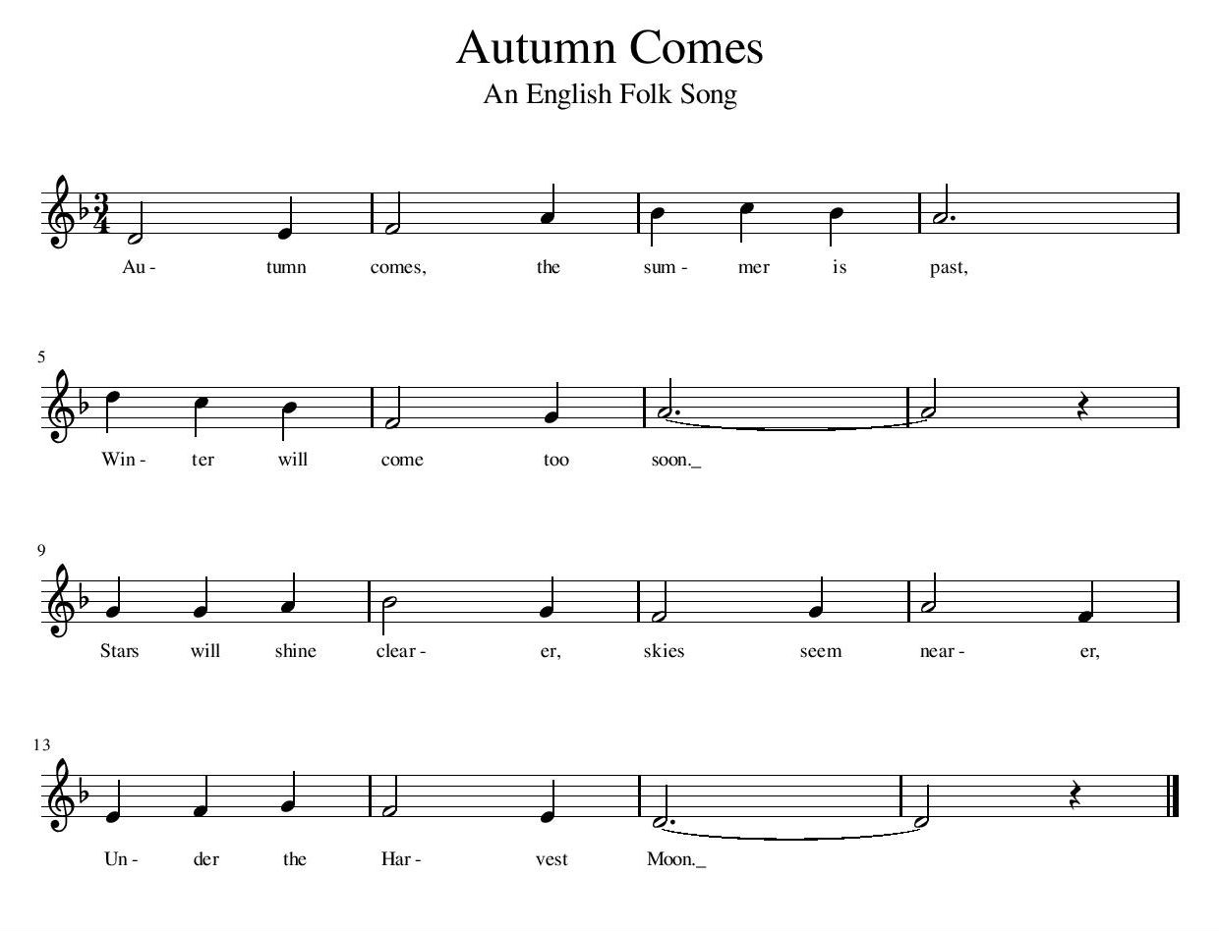
From what I could gather from a source that isn’t terribly reliable (a youtube video title): this song was composed in the 16th century.

